# Activity 13: Representations



### CATEGORY: FUNCTIONS

### DOMAIN: INTERPRETING FUNCTIONS

**Analyze functions using different representations.**

* Graph functions expressed symbolically and show key features of the graph, by hand in simple cases and using technology for more complicated cases.
* Write a function defined by an expression in different but equivalent forms to reveal and explain different properties of the function.
* Compare properties of two functions each represented in a different way (algebraically, graphically, numerically in tables, or by verbal descriptions). *For example, given a graph of one quadratic function and an algebraic expression for another, say which has the larger maximum.*

### LEARNING OBJECTIVES

Students will be able to sketch the graph of a function by noticing aspects of the symbolic form. Students should begin to understand that expressing functions in different forms would highlight different characteristics of the function. Students should be able to compare two functions even when they're both represented differently.

### Define, evaluate, and compare functions.

* Compare properties of two functions each represented in a different way (algebraically, graphically, numerically in tables, or by verbal descriptions). *For example, given a linear function represented by a table of values and a linear function represented by an algebraic expression, determine which function has the greater rate of change.*

### Activity 1 3 : Getting Started





### GETTING STARTED

To become efficient, and eventually proficient, with the ability to graph functions, students must be able to visualize aspects of the function simply by looking at it’s symbolic representation. This ability can be honed by understanding how the parent [simplest form]

of the most common functions will look like when they are graphed. The following are examples of some common parent functions:

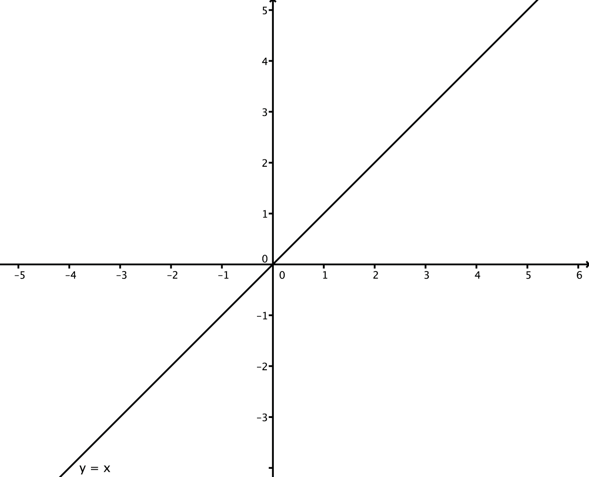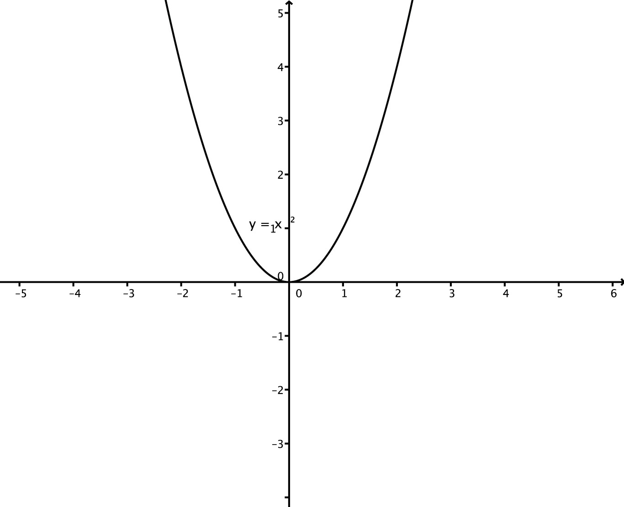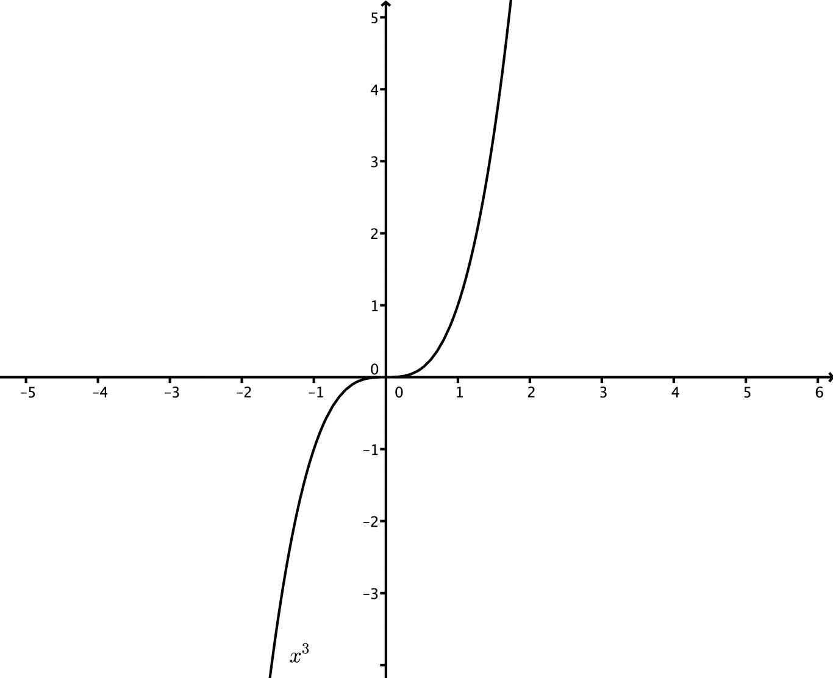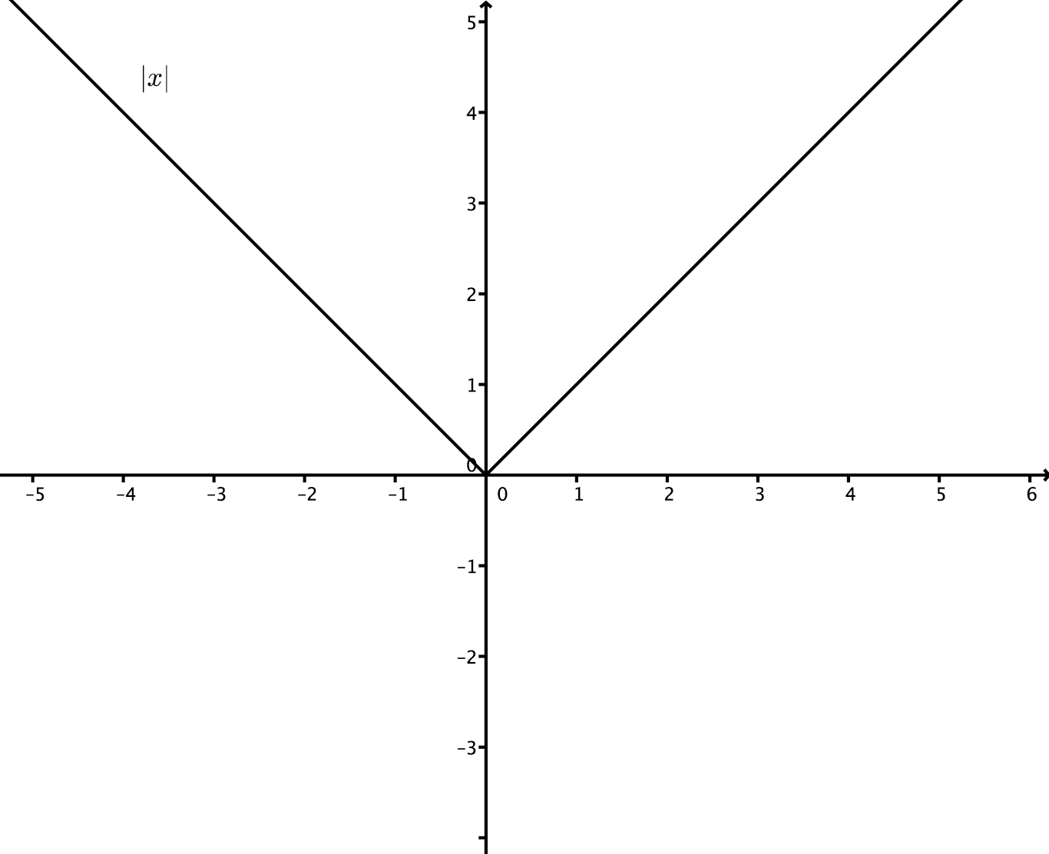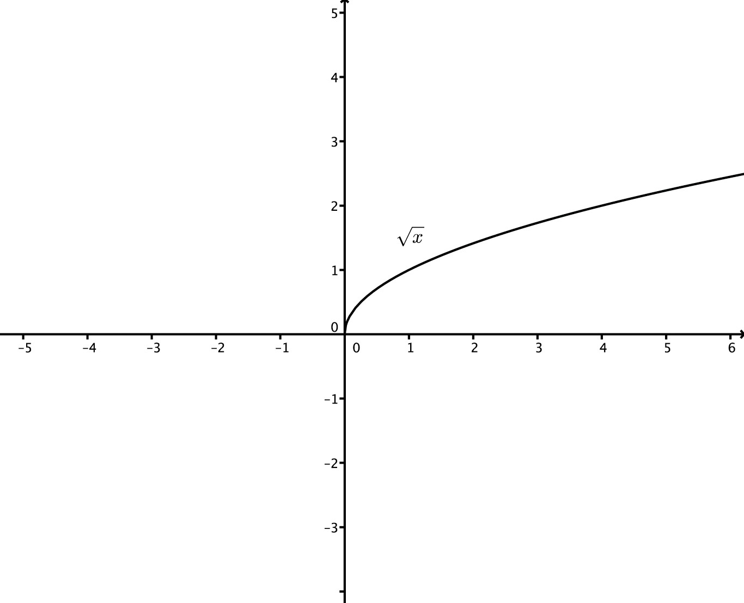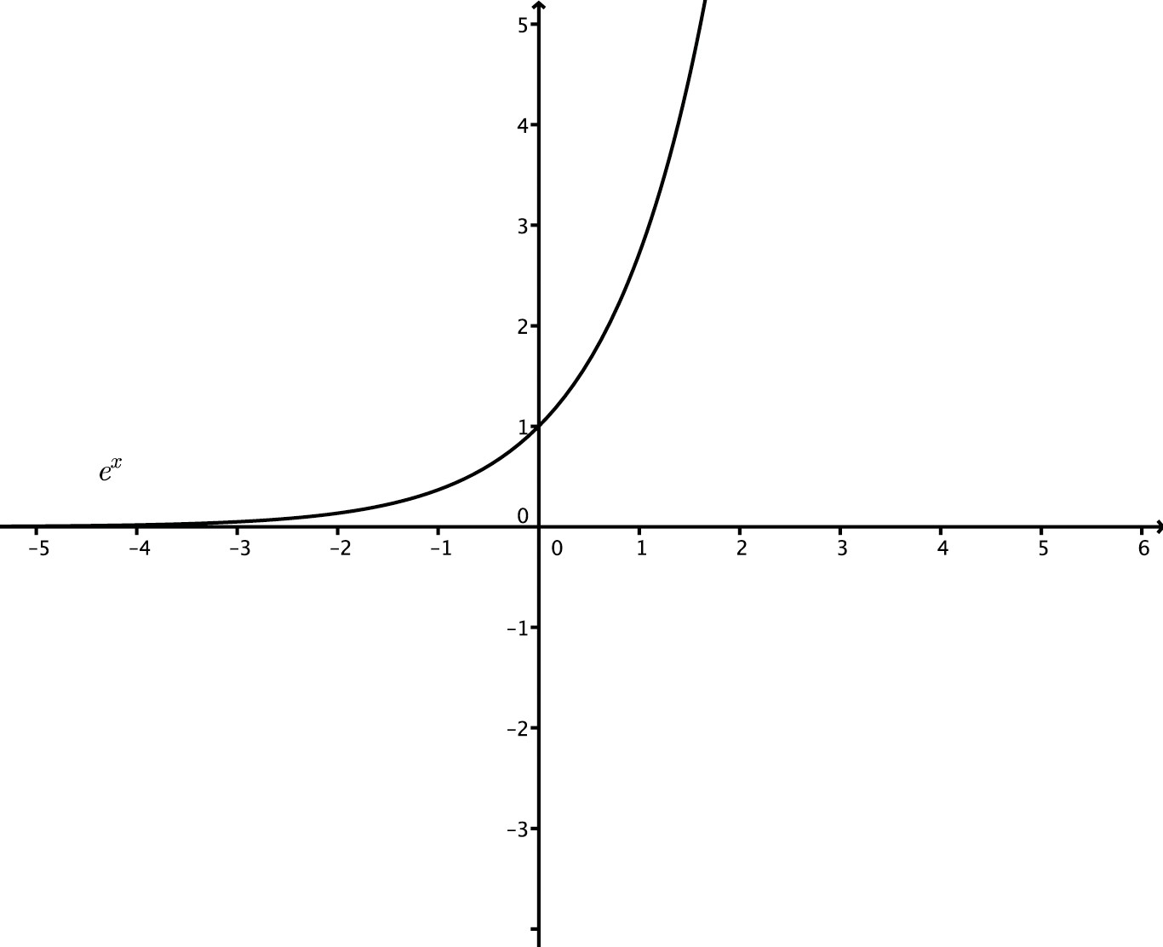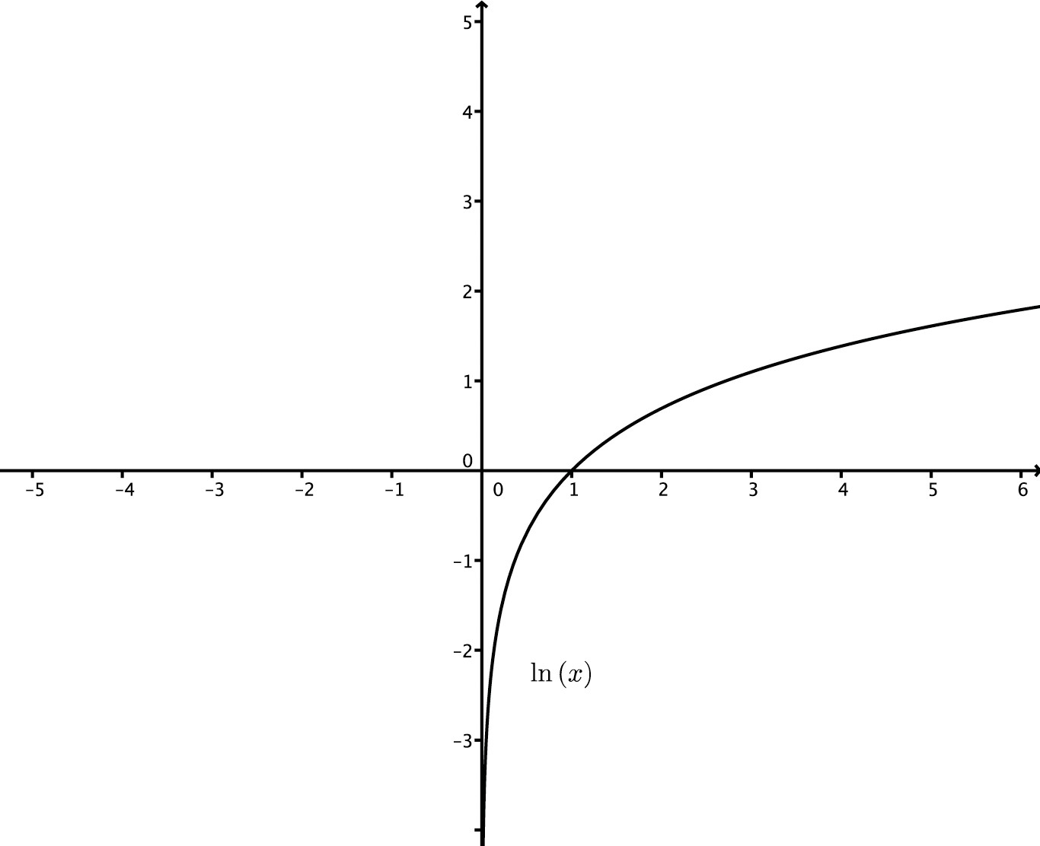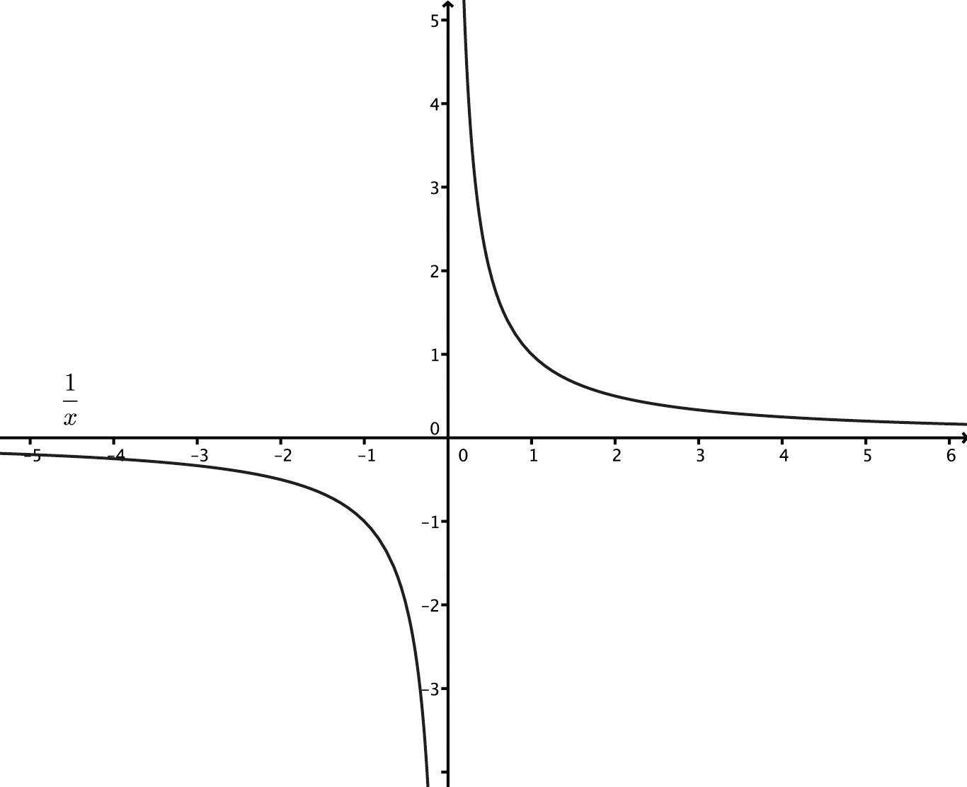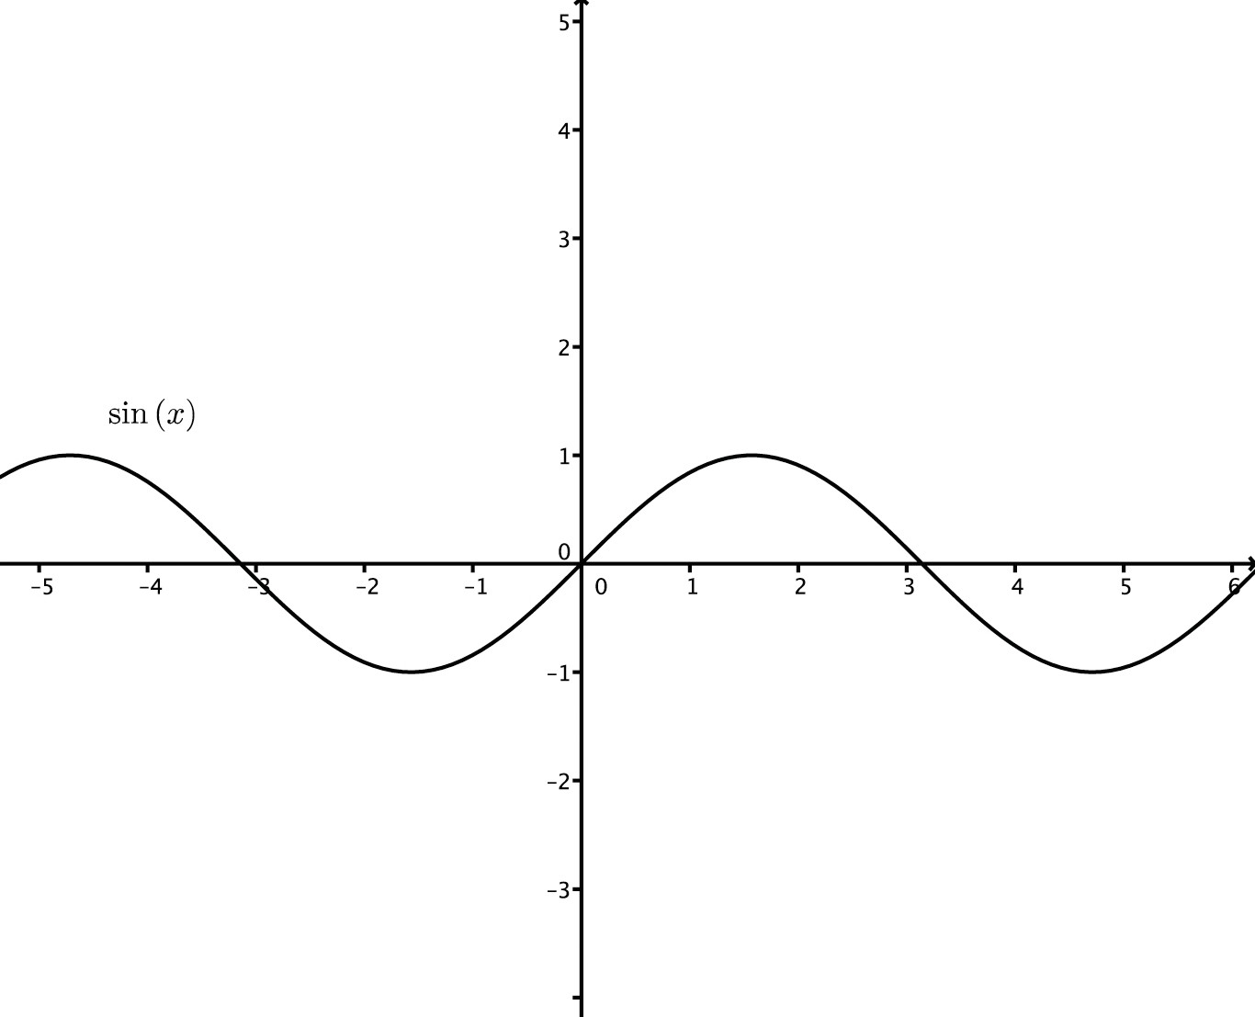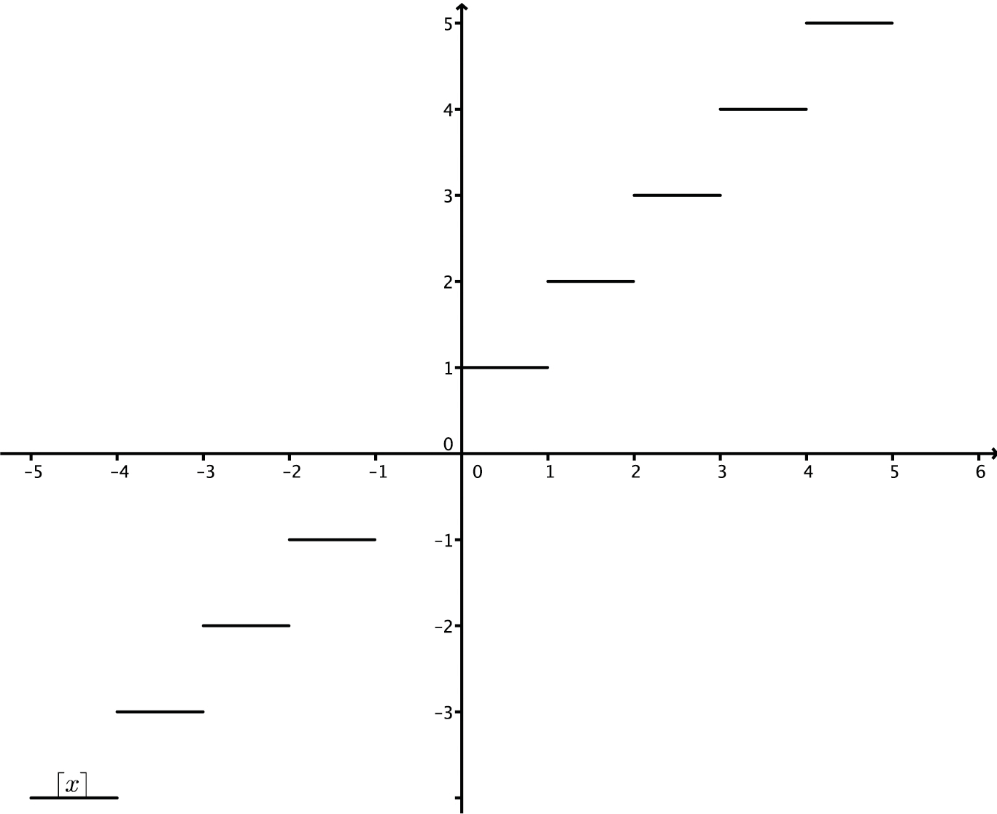

### UNDERSTAND

1. An exponential function *P* defined as *P* (𝑥) = *a· b*𝑥has this table of inputs and outputs. Find the values of *a* and *b*.

|  |  |
| --- | --- |
| **𝑥** | **P(𝑥)** |
| -2 | 108 |
| -1 | 36 |
| 2 | 4  3 |

1. Given the functions *y* = sin 𝑥and *y* = 0.6, the least positive value of 𝑥that solves sin 𝑥= 0.6 is 37˚. Find the next two values.
2. Given the functions *y* = sin 𝑥and *y* = cos 𝑥, find two values of 𝑥where sin 𝑥= cos 𝑥.

### Activity 1 3: Getting Started





### PRACTICE

1. Which of the following could be the function of a real variable 𝑥whose graph is shown below?

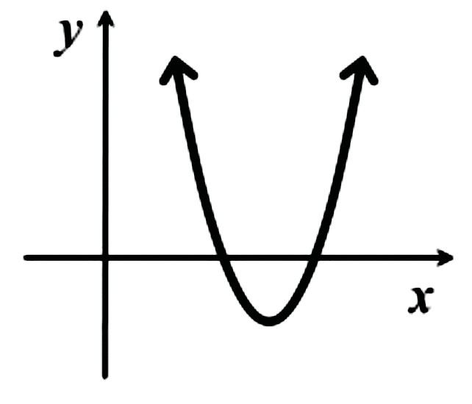

🔾 *f*1(𝑥) = (𝑥+ 12)2 + 4

🔾 *f*2(𝑥) = –(𝑥– 2)2 – 1

🔾 *f*3(𝑥) = 3𝑥2 – 4𝑥+ 1

🔾 *f*4(𝑥) = (𝑥+ 4)(𝑥– 6)

🔾 *f*5(𝑥) = (𝑥– 12)2 – 9

1. Suppose Brett and Andre each throw a baseball into the air. The height of Brett’s baseball is given by *h*(*t*) = –4.9*t*2 + 30*t* + 2, where *h*, is in meters and *t* is in seconds.

The height of Andre’s baseball is given by the graph below:

* 1. Brett claims his ball went higher than Andre’s, and Andre says his baseball went higher than Brett’s. Who is correct?
  2. About how long was each baseball in the air?

### Activity 1 3: Getting Started





### EXTEND

1. Pictured below are the graphs of four different functions defined in terms of eight constants: *a*, *b*, *c*, *k*, *m*, *p*, *q*, and *r*. The equations are:

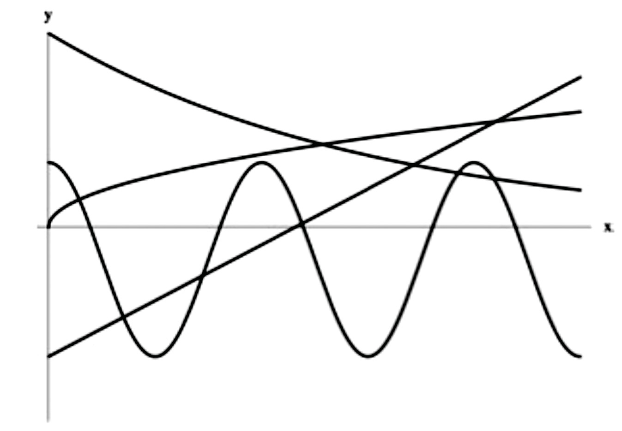

1

2

3

4

* *y = m*𝑥 *+ b*
* *y* = *acos*(𝑥) + *c*
* *y* = *qr*𝑥
* *y* = *k*𝑥*p*
  1. Match each equation with its graph.
  2. Which constants must be negative?
  3. Which constants must be positive?
  4. Which constants are greater than zero but less than one?
  5. Which constants must be greater than one?