Activity 7: Model This

CATEGORY: ALGEBRA

DOMAIN: CREATING EQUATIONS

Create equations that describe numbers or relationships.

- Create equations and inequalities in one variable and use them to solve problems. Include equations arising from linear and quadratic functions, and simple rational and exponential functions.

- Create equations in two or more variables to represent relationships between quantities; graph equations on coordinate axes with labels and scales.

- Represent constraints by equations or inequalities, and by systems of equations and/or inequalities, and interpret solutions as viable or nonviable options in a modeling context. For example, represent inequalities describing nutritional and cost constraints on combinations of different foods.

- Rearrange formulas to highlight a quantity of interest, using the same reasoning as in solving equations. For example, rearrange Ohm's law, V = IR, to highlight resistance, R.

LEARNING OBJECTIVES
Students should be able to interpret word problems and form equations and inequalities in order to solve the problem. Students should be able to translate word problems into equations with two or more variables, create graphs of equations on coordinate axes and interpret the results of these actions. Finally, students should be able to match commonly encountered formulas to context in word problems, as well as, rearrange them to solve for whatever value they want.

Reason about and solve one-variable equations and inequalities.

1. Use variables to represent numbers and write expressions when solving a
real-world or mathematical problem; understand that a variable can represent an unknown number, or, depending on the purpose at hand, any number in a specified set.

Activity 7: Getting Started


GETTING STARTED
You can use quadratic functions to model real-world situations. Optimization problems use quadratic functions to determine the greatest area for a rectangular region.

- Suppose that you have 200 meters of fencing to use for building a rectangular dog pen. Find the dimensions of the pen having the greatest possible area.

- Suppose you build the pen such that it borders a building. You will need only to build three walls. Find the dimensions of the pen having the greatest possible area.

Activity 7: Getting Started


- Suppose that you have three pets, a dog, a cat, and a monkey. You want to divide the
pen into three smaller rectangular sections. There will be one pen for each animal. The pens will be side by side as shown below.

You still only have 200 meter of fencing. You will have to use some of the fencing to build the dividers between the pens. You want to maximize the area of the entire pen. What should the dimensions be?

- Suppose you build a pen to separate five goats. You have 600 meters of fencing. What dimensions give the maximum area for the entire pen?

- Explain the pattern to the solutions of Problems #1 - 4 in as much detail as possible.

Activity 7: Getting Started


UNDERSTAND
In modeling linear functions, you may have already discovered that for abscissas (x-values) that are evenly spaced, the differences between the corresponding ordinates (y-values) must be the same. With 2nd and 3rd-degree polynomial functions, the differences between the corresponding ordinates are not the same. However, finding the differences between those differences produces an interesting pattern.

1st degree: y = 3𝑥 + 4

𝑥 | 2 | 3 | 4 | 5 | 6 | 7
y  Δ₁ | 10 | 13 | 16 | 19 | 22 | 25
 |  | 3 | 3 | 3 | 3 | 3

2nd degree: y = 2𝑥² – 5𝑥 – 7

x | 3.1 | 3.8 | 3.9 | 4.0 | 4.1 | 4.2
y | 1.88 | 2.88 | 3.92 | 5.00 | 6.12 | 7.28
Δ₁ |  | 1 | 1.04 | 1.08 | 1.12 | 1.16
Δ₂ |  |  | 0.04 | 0.04 | 0.04 | 0.04

3rd degree: y = 0.1𝑥³ – 𝑥² + 3𝑥 – 5

x | -5 | 0 | 5 | 10 | 15 | 20
y | -57.5 | -5 | -2.5 | 25 | 152.5 | 455
Δ₁ |  | 52.5 | 2.5 | 27.5 | 127.5 | 302.5
Δ₂ |  |  | -50 | 25 | 100 | 175
Δ₃ |  |  |  | 75 | 75 | 75

Note, that in each case, the x-values are spaced equally. You find the first set of differences, Δ₁, by subtracting each y-value from the one after it. You find the second set of differences, Δ₂, by subtracting the consecutive Δ₁values in the same way.

For the 2nd-degree polynomial function, the Δ₂ values are the same, and for the 3rd-degree

polynomial function, the Δ₃ values are constant.
- What do you think will happen with a 4th or 5th-degree polynomial function?

Activity 7: Getting Started


- Find a polynomial function that models the relationship between the number of sides
and the number of diagonals of a convex polygon. Use the function to find the number of diagonals of a dodecagon (a 12-sided polygon).

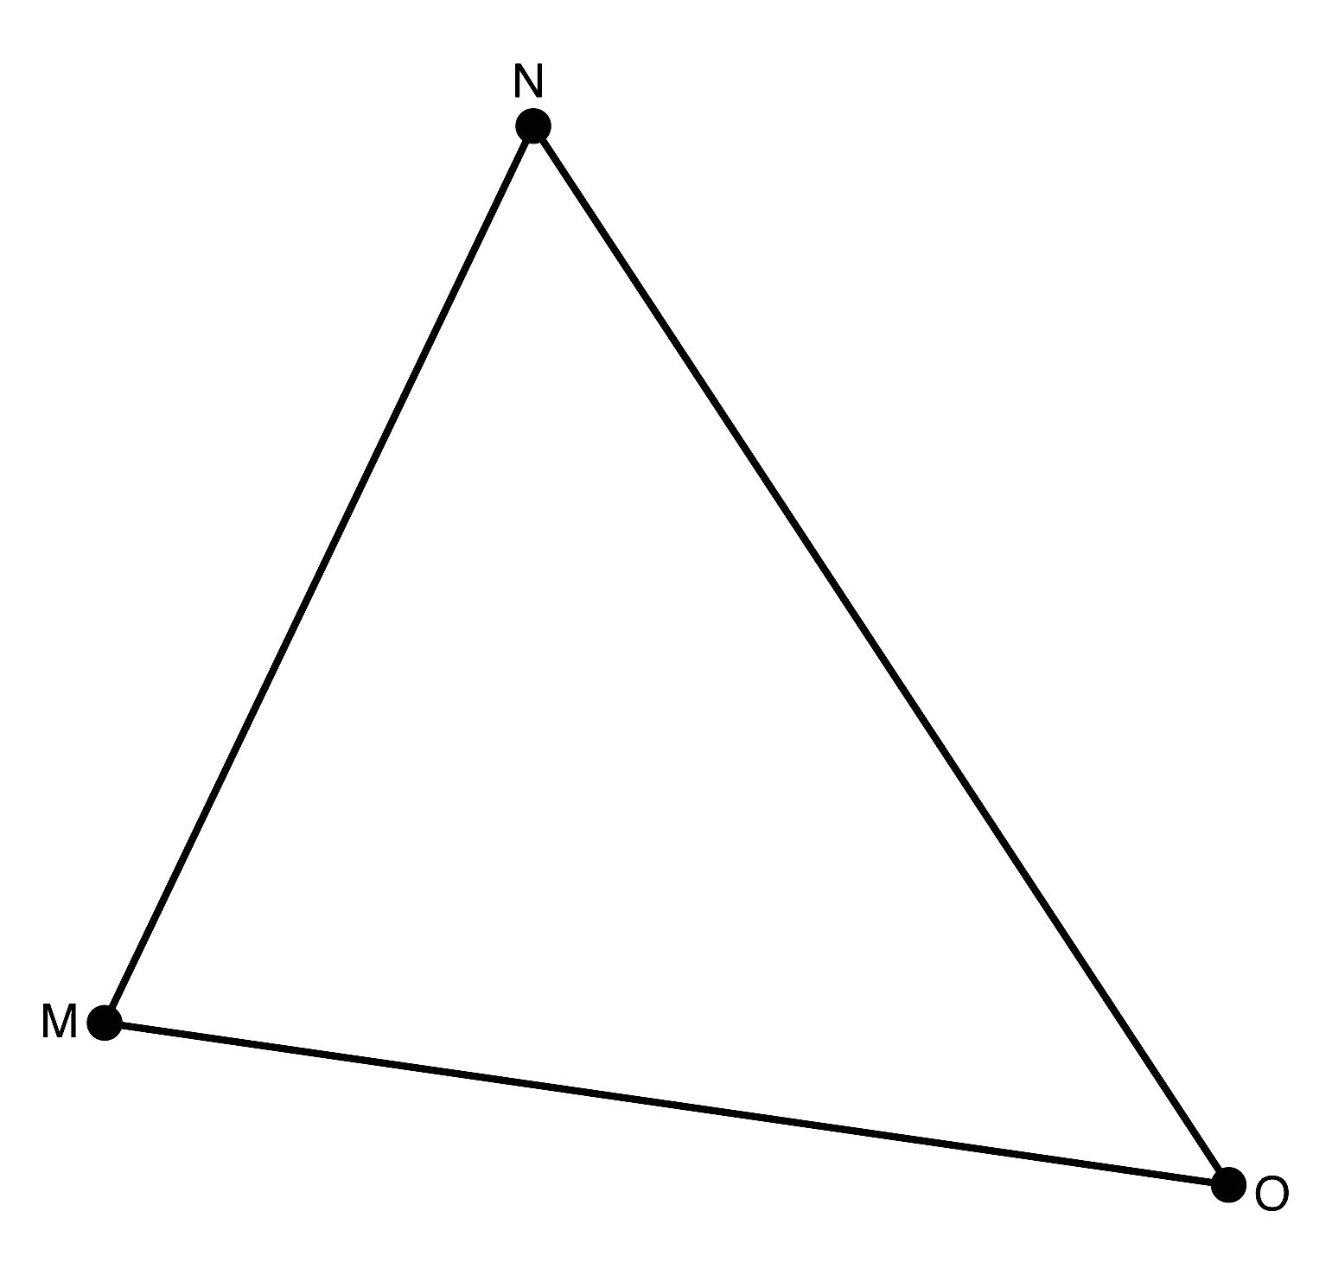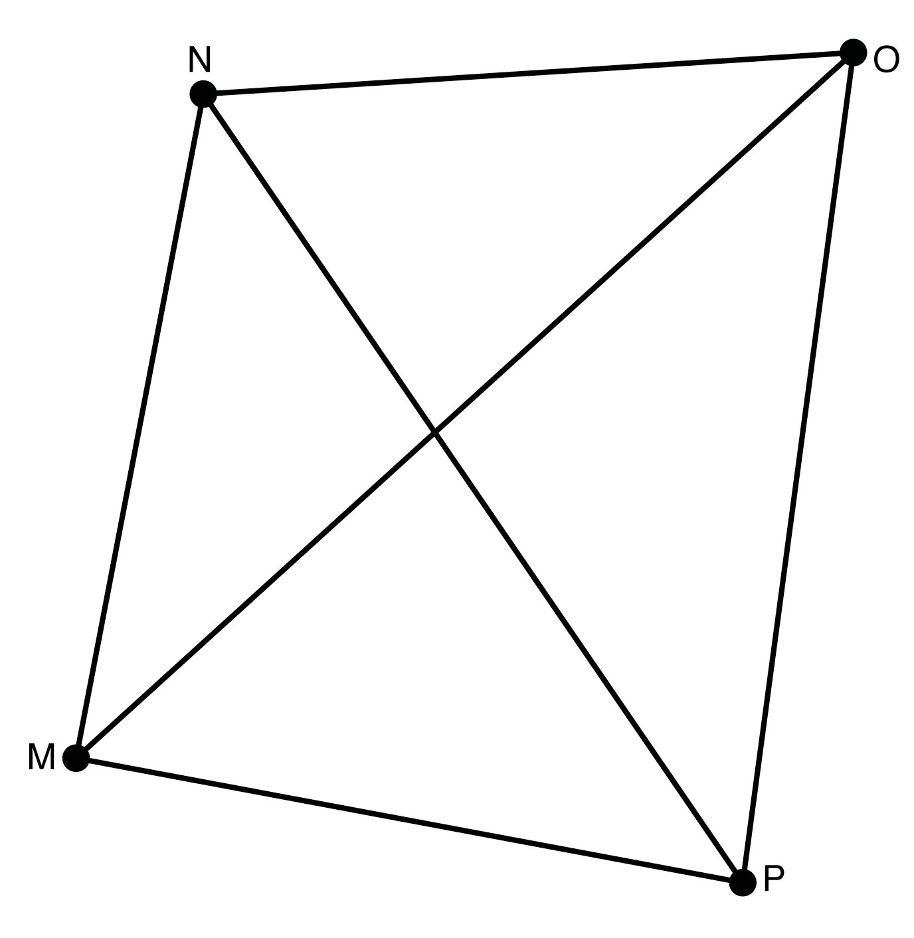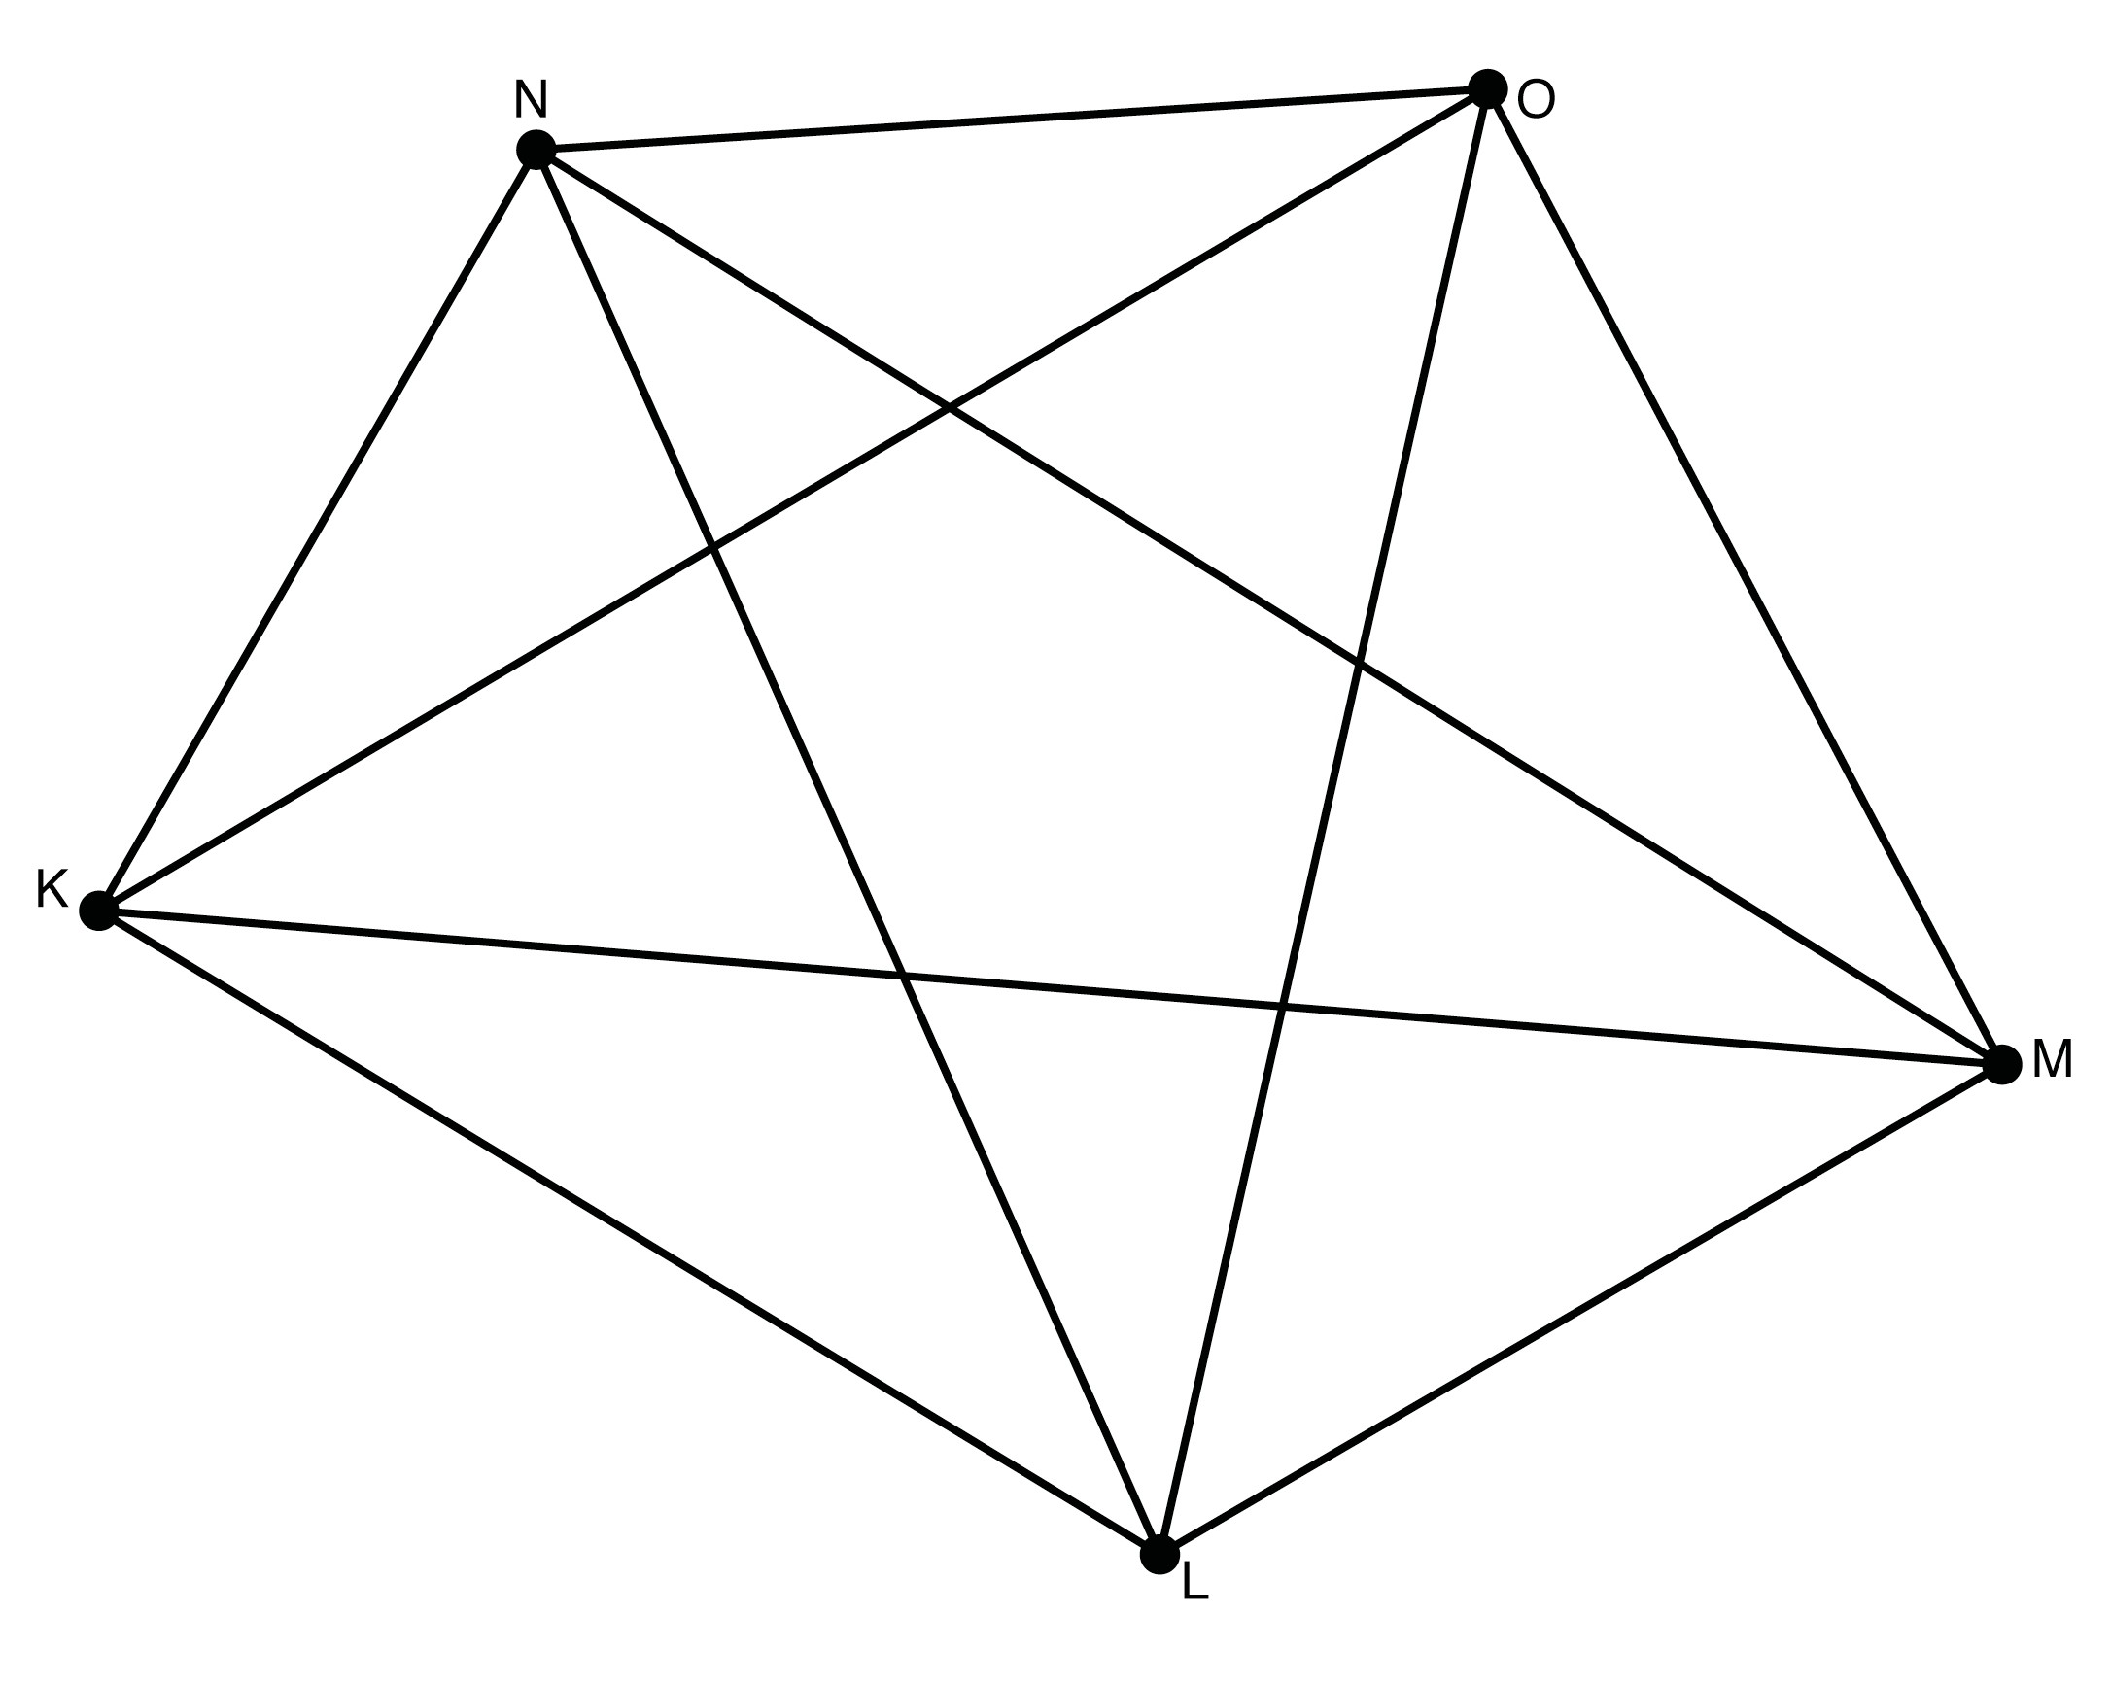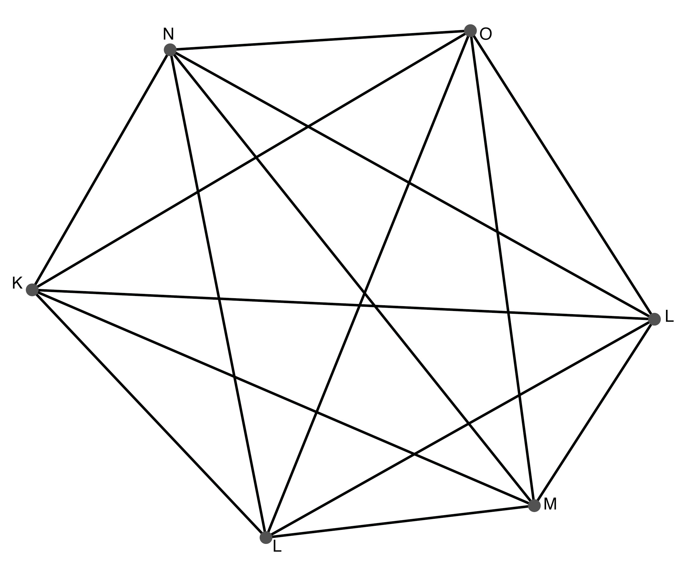

PRACTICE
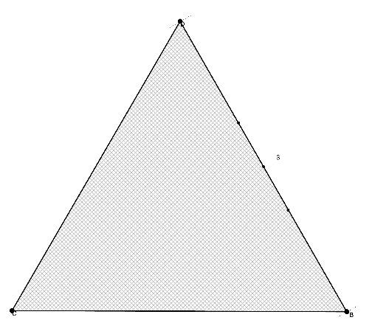
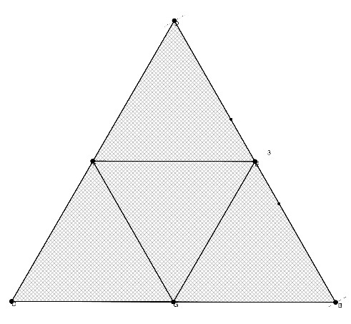
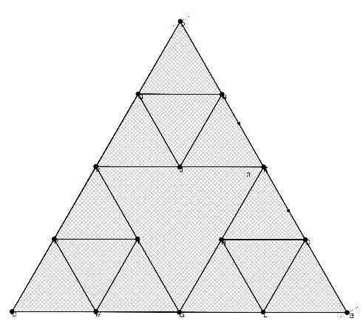
- A recursive rule defines the first three stages of a sequence of shapes. The first shape is an upward-pointing triangle. To find the next shape, draw a downward-pointing triangle in the middle of every upward-pointing triangle

stage 1 stage 2 stage 3 Find a rule that gives the number of upward-pointing triangles at each stage.
In stage 1, there is only one larger triangle, and it is pointing upwards. In stage 2, there are four smaller triangles, three of which are pointing upwards, and so on.

  - Draw stage 4 of this sequence. Using your drawing and the drawings above, copy and complete this table.

Stage | Number of Upward-Pointing Triangles
1
2
3
4

Activity 7: Getting Started


  - Find a function that matches the table in part (a).

  - Find a function that has the number of downward-pointing triangles for each stage as its output.

EXTEND
- Suppose a student named Marcus throws a ball straight up next to a building. The ball’s height in meters after t seconds is given by –4.9t² + 27t + 2. Jana rides a glass elevator down the outside of the same building. Her height from the time Marcus throws the ball can be expressed as 43 – 5t. As Jana is riding down, she sees a bird fly by above the elevator but below the ball. When did Jana see the bird? Give a range of possible times.

