Activity 6: Basic Operations

CATEGORY: ALGEBRA
DOMAIN: SEEING STRUCTURE IN EXPRESSIONS

Perform arithmetic operations on polynomials.

- Understand that polynomials form a system analogous to the integers, namely, they are closed under the operations of addition, subtraction, and multiplication; add, subtract, and multiply polynomials.

LEARNING OBJECTIVES
Students should know that a polynomial is any expression that is a combination of more than one term using addition, subtraction or multiplication. Each individual term is called a monomial. Students should understand that monomials can be constant or include variables to different degrees.

Use properties of operations to generate equivalent expressions.

  - Apply properties of operations as strategies to add, subtract, factor, and expand linear expressions with rational coefficients.

Activity 6: Getting Started


GETTING STARTED
Students should understand that polynomials, like integers, are "closed" when it
comes to addition, subtraction, and multiplication. Basically, this just means they're kind
of exclusive as far as these operations are concerned. An integer plus an integer is an integer, an
integer minus an integer is an integer, and an integer times an integer is an integer.
Similarly, a polynomial plus a polynomial is a polynomial, a polynomial minus a polynomial is a polynomial, and a polynomial times a polynomial is a polynomial. If that isn't cliquey, we don't know what is.

If addition and subtraction pair terms that go together, then multiplication combining any and all terms together in one pile regardless of what they are. Students should know that multiplying a polynomial by a monomial means distribution, and that multiplying two polynomials together means a lot of distribution. More specifically, we have to make sure to multiply every term in one polynomial by every term in the other polynomial.

- Even though lengths and areas are not negative, you can use rectangle diagrams to represent individual terms and products. Copy each rectangle diagram and fill in the missing values to show the products and quotients of two polynomials.

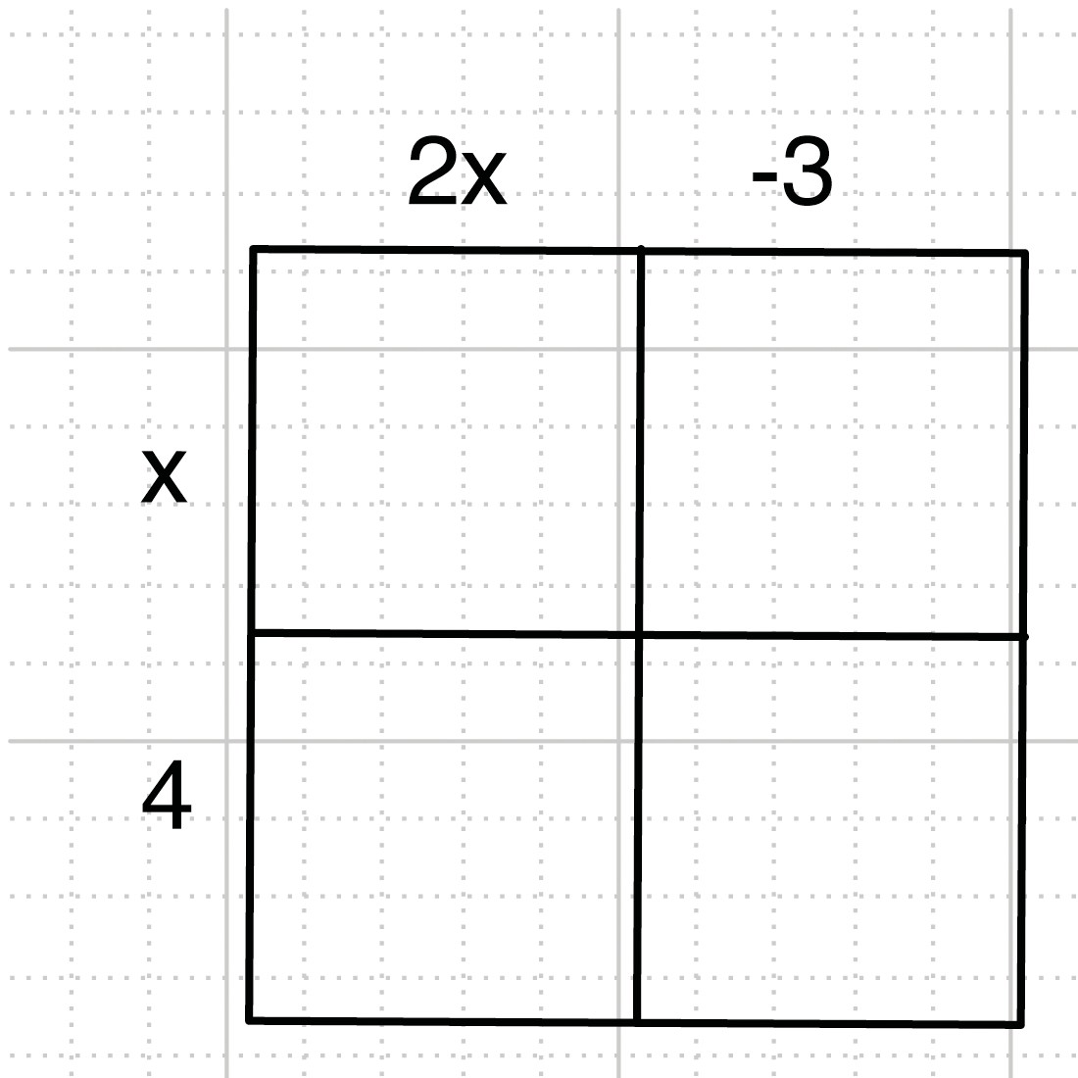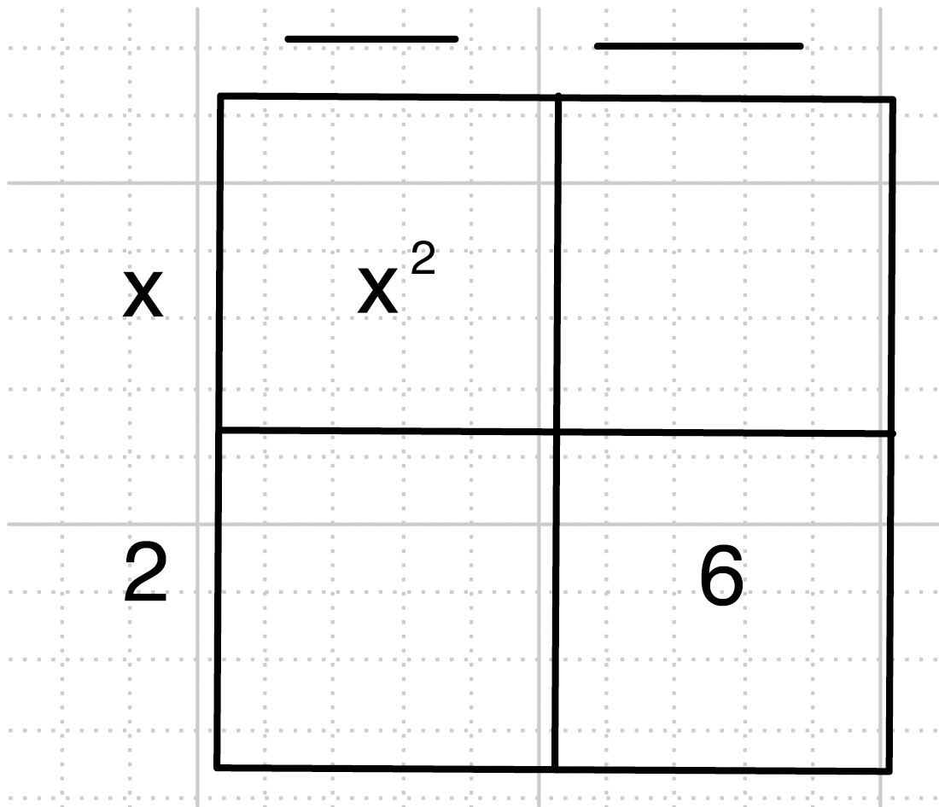
2𝑥
-3
𝑥
4
6
𝑥²
𝑥
2

UNDERSTAND
- For each problem below, is each result always a polynomial? Explain.

  - Sum of two polynomials

  - Product of two polynomials

  - Difference of two polynomials

  - Quotient of two polynomials

Activity 6: Getting Started


PRACTICE
- Find two polynomials with the same degree that have a sum of 3𝑥² + 7𝑥 + 4.

- Find two polynomials with different degrees that have a sum of 3𝑥² + 7𝑥 + 4.

- Find two polynomials that have a product of 𝑥² – 1.

EXTEND
- Suppose you make a frame for a square photo. The frame is 2 centimeters wide. Find the area of the frame if the photo has the following dimensions.

  - 3 cm. by 3 cm.
2 cm.

  - 9 cm. by 9 cm.

  - 𝑥 cm. by 𝑥 cm.
2 cm.

