**The Use Classwiz for Trigonometry Exploration**

**By : Chandra Sri Ubayanti**

Trigonometry exploration is easily done using Classwiz, one of which is the angle relationship between quadrants. For example, determining relationships between quadrants through Classwiz. Through the spreadsheet function, classwiz can take the following steps:

1. Select the spreadsheet menu w8

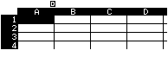

1. In the Cell A input angle, i.e. from up to , step per corner is 

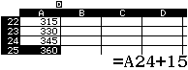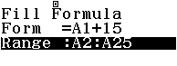

1. On Cell B1 input value of 

T1jQz1)=$$$$$$o25=

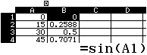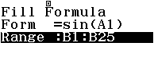

1. On Cell B1 input value of 

T1kQz1)=$$$$$$o25=

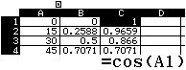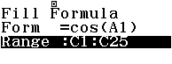

1. On Cell B1 input value of 

T1lQz1)=$$$$$$o25=

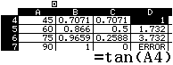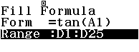

Exploration of the angular relations above is very useful for students, through the spreadsheet function students can see a direct comparison of relations between quadrants, and trigonometric values which are positive or negative in a quadrant. This learning in addition to making students proficient using spreadsheet functions can also explore trigonometry to a higher level, for example drawing graphics manually.

Calculator Classwiz are tools to help students embed concepts with fun activities and trigger their thinking creativity. Triginometric formulas inputted at scratch can be asked for students to formulate in calculators, so that students' creativity in practicing trigonometry concepts can be done on many devices.

One of them is the spreadsheet function in the calculator classwiz which can manipulate trigonometric concepts. Classwiz can be done as follows:

1. Select the spreadsheet menu w8



1. Cell A is a value of B angle to be inputted (blank because it will be manually inputted)
2. Cell B is the length of side b to be inputted (blank because it will be manually inputted)
3. Cell C1 is the side length a, then input the following formula 

T1Qx1PlQz1)=$$$$$$o5=

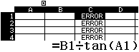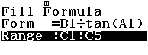

Error is seen because there is no input value for Cell A and Cell B

1. Cell D1 is the side length c, then input the following formula 

T1Qx1PjQz1)=$$$$$$o5=

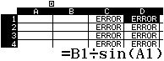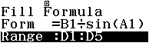

1. Cell E1 is the angle A obtained from 

T190pQz1=$$$$$$o5=

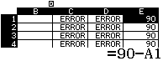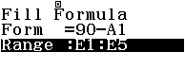

1. Input Cell A for angle B (under  ) and Cell B for side length b

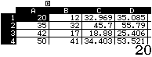

1. Ask students to investigate the values that come out in the table, then compare them with the results of scratch coding and manual calculations as affirmations