**GROWTH AND DECAY**

**Chandra Sri Ubayanti**

Calculators could help students solve HOTS questions that are not just counting, but students are expected to analyze and evaluate questions, form mathematical models, and then solve them with a calculator. On the other hand, calculators are not only used in examinations, but also in learning so that students do not understand the problem and then assist with a calculator.

***Example 1.*** One of the problems with the HOTS National Exam is the following:

Every year the selling price of land in a residential complex increased 20% from the previous year, while the selling price of the building decreased 5% from the previous year. The selling price of a house (land and building) is currently in the complex if 5 years ago purchased for 210 million IDR and the comparison of land selling price to the building at the first time buy 4: 3 is ...

***Solution.*** Calculator may not be used directly for the HOTS model. In the learning process, teachers need to do the learning steps so that students' ability is in high proficiency that is as follows:

1. Students are directed to learn and collaborate collaboratively through groups
2. Ask and guide students to think logically understand the content of the problem and reasoning the language of the story on the matter
3. Students start analyzing the Mathematical model for solving the problem, separating various issues from initial purchase, land price increase, decay of house price and projected selling price per year, ie :
4. The selling price of land and building is the first time when buying





1. The selling price of land occurs in price increases per year 

While house prices are declining in price per year 

The price of land and house each year becomes 

1. Students evaluate the results of the discussion in their group related to the mathematical concepts that have been analyzed. So that

The price of land per year becomes



The price of house per year becomes



1. Creating the Mathematical Concept of the problem solving, including completing it in Classwiz scientific calculator assisted using spreadsheet mode, as follows :
2. Press Menu 8 on calculator

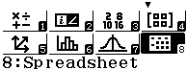w8

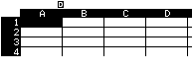

1. Suppose Cell A is the number of years, then simulate up to 10 years (type 1 through 10).

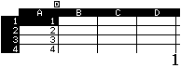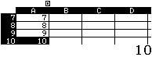

1. Cell B is an increase in land prices. Place the cursor on Cell B1 and then input the formula through the calculator button as follows:

T1120(1+20qM)^Qz1)=

for the formula of land price per year 

$$$$$$0== for the result cell range

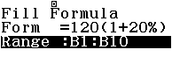

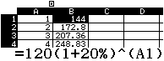

1. Cell C is the decay of house prices. Place the cursor on Cell C1, input through the calculator button as follows :

T190(1p5qM)^Qz1)=

For the the formula of house prices per year 

$$$$$$0== untuk range cell hasil

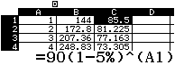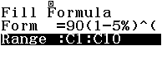

1. Cell D is the selling price of land and house per year, is the sum of Cell B and Cell C. Place the cursor on Cell D, press the following button in the Calculator :

T1Qx1+Qu1= Cell B + Cell C

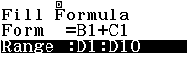$$$$$$0== for the result cell range

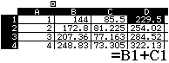

1. From the table in Cell D, the projected sales of land and house price are recorded every year. For example for the next 5 years the price of home sales is IDR 368.23 million.
2. Each group of students is asked to communicate the results and express their learning experiences as part of the student learning feedback.

In the examination, the calculator can function as computation, so it does not require the step of achieving the concept as above. If the question of the sale price of land and house in the fifth year then simply inputkan mathematical expression as follows:

w1 Computation Mode

120(1+20qM)^5$+90(1p5qM)^5= Input 

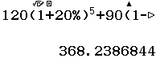

Proceeds from the sale of land and houses in the fifth year