Numerical patterns
ALGEBRA
05

Number of polygons
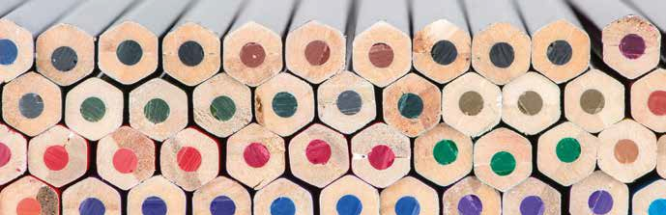
Laura stacks her colored pencils in rows so that each pencil in a row is placed between two pencils in the bottom row. He has constructed a ten-row pyramid with pencils and wonders how many pencils he has and how many pencils he would need to stack 15 rows.
In mathematics, we say that a number is polygonal if points, stones, coins, etc. it can be recomposed in the form of a regular polygon represent it. There are triangular, square, pentagonal, hexagonal numbers ... Then we will discover them and work with some of their properties.

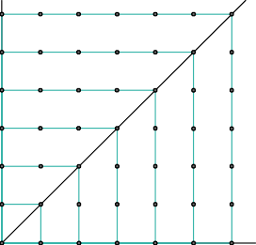
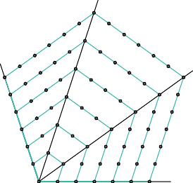
Observe the attached figures and complete the table with the number of points in each figure according to the
1
value of n:
n=1 n=2 n=3 n=4 n=5 n=6 n=7 n=1 n=2 n=3 n=4 n=5 n=6 n=7 n=1 n=2 n=3 n=4 n=5 n=6 n=7

 |  |  | n
 |  |  | 1 | 2 | 3 | 4 | 5 | 6 | 7
Sides of the polygon (p) | 3 | Triangles | 1 | 3 | 6 | 10 | 15 | 21
 | 4 | Squares | 1 | 4 | 9
 | 5 | Pentagons | 1 | 5 | 12
 | 6 | Hexagons | 1 | 6 | 15

Consider now the number of points that is added to each figure with respect to the previous figure and complete the table.
2

 | n
 | 1 | 2 | 3 | 4 | 5 | 6 | 7
Triangles | 1 | 2 | 3 | 4
Squares | 1 | 3 | 5 | 7
- Can you write more terms of the sequence of differences? Why?
- Can you write the general term of the sequence of differences for hexagonal, heptagonal and octagonal numbers? Can you reconstruct the corresponding polygonal sequence of numbers?

Calculate the eighth, ninth and tenth triangular numbers
3

This teaching material is written by the Federación Española de Sociedades de Profesores de Matemáticas (FESPM) and other authors.

You can use and alter the teaching material for educational purposes, however the use of it for the purpose of sales is prohibited.

