Parameters: calculation and interpretation
STATISTICS
06
Grades in mathematics
Below are the grades that have been taken by some students of 4 classes in Math at the sophomore level: x is the number of pages of notes taken. F is the frequency

Class A | x | 0 | 1 | 2 | 3 | 4 | 5 | 6 | 7 | 8 | 9 | 10
 | Fi | 0 | 0 | 0 | 0 | 10 | 15 | 5 | 1 | 0 | 0 | 0

Class B | x | 0 | 1 | 2 | 3 | 4 | 5 | 6 | 7 | 8 | 9 | 10
 | Fi | 0 | 1 | 3 | 5 | 8 | 8 | 7 | 2 | 2 | 1 | 1

Class C | x | 0 | 1 | 2 | 3 | 4 | 5 | 6 | 7 | 8 | 9 | 10
 | Fi | 2 | 3 | 3 | 4 | 3 | 2 | 3 | 3 | 1 | 4 | 2

Class D | x | 0 | 1 | 2 | 3 | 4 | 5 | 6 | 7 | 8 | 9 | 10
 | Fi | 7 | 6 | 3 | 0 | 1 | 2 | 2 | 2 | 1 | 5 | 7

Calculate the mean, median and mode of each class. Does the average provide sufficient knowledge about the mathematics performance of the 4 classes? Why?
1

Build a bar graph for each class. What can you say about the notes of each class?
2

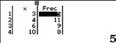
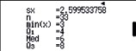
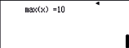
We have introduced a series of notes in the calculator and we have obtained the following statistical parameters.
3
- What do the values for n, min (x) and max (x) mean in context?
- Now look at the values of the quartiles (Q1, Q2 = Med and Q3). How do you think they have been calculated? What do you think they mean?
- The following box and whisker plot has been obtained from the data. What values are represented? How do you think it has been done?
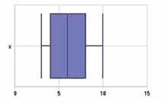

Build the box and whiskers plot for the notes of the 4 classes sophmores. What can you say now about the notes of each class?
4

This teaching material is written by the Federación Española de Sociedades de Profesores de Matemáticas (FESPM) and other authors.

You can use and alter the teaching material for educational purposes, however the use of it for the purpose of sales is prohibited.

