Fractals: the Koch curve
ALGEBRA
10
Fractals in snowflakes
In 1904 the Swedish mathematician Helge von Koch divided a segment into three equal parts, eliminated the central segment and constructed an equilateral triangle whose base was the eliminated segment.
Repeated the previous process indefinitely and obtained a polygonal curve known as the Koch curve.
The application of this reiterative process on the sides of an equilateral triangle gives rise to the one known as Koch's snowflake.
Original Triangle n = 1 n = 2 n = 3

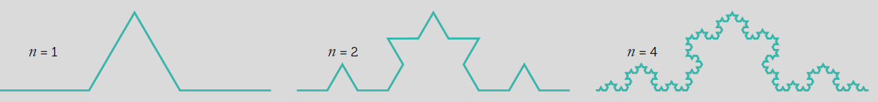

Draw on the template the third iteration.
1

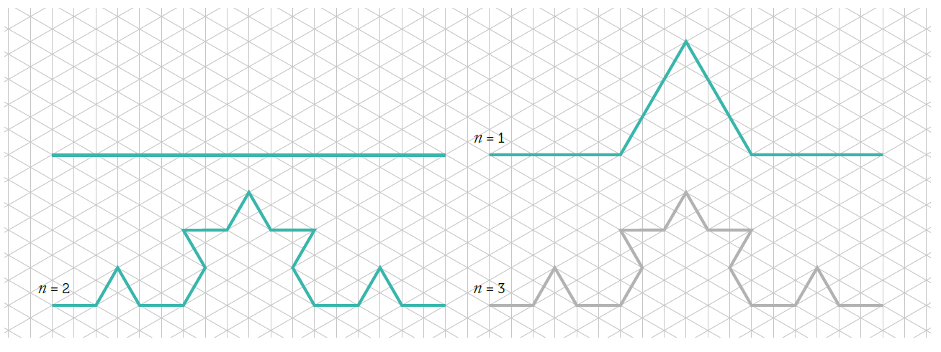

Complete the following table, starting from a segment of 1 unit in length:
2

Iteration | 1 | 2 | 3 | 4 | 5 | 6 | ... | k | ...
No. of segments | 4 |  |  |  |  |  | ... |  | ...
Length of segments | 1 3 |  |  |  |  |  | ... |  | ...
Sum of all segments | 4  3 |  |  |  |  |  | ... |  | ...
  - Find the recursive rule that allows knowing the number of segments to obtain the k-th iteration.
  - Can you get a rule that allows you to know the length of the segments, and the sum of all the segments in the k-th iteration, and the number of triangles that are added in each iteration?
  - Are the formulas you have obtained in the previous section similar to any model you have studied in class?

This teaching material is written by the Federación Española de Sociedades de Profesores de Matemáticas (FESPM) and other authors.

You can use and alter the teaching material for educational purposes, however the use of it for the purpose of sales is prohibited.

