Operations
ARITHMETIC
16
Decomposition of continuous fractions
A continuous fraction is an expression:

Where a, b, c, ... are positive integers called quotients.

Any rational number, that is, any number that can be represented by a fraction $\frac{p}{q}$,

can be expressed in the form of a finite continuous fraction.

Regarding irrational numbers, they can be expressed in the form of an infinite continuous fraction.
In the particular case of quadratic irrational numbers, that is, those that can express a +$\sqrt{ b}$, the ratios of the corresponding continuous fractions are repeated periodically. For example, the
irrational number $\sqrt{2}$ can be expressed in the form of an infinite continuous fraction such as:

In this case, the quotients of the continuous fraction (1; 2,2,2,2, ......) are repeated periodically and are represented as (1; $\overline{2}$).
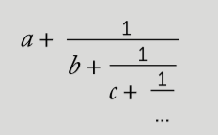

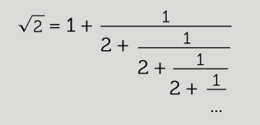

Write the fraction in the form of a continuos fraction.
1

Express in the form of an irreducible fraction the continuous fraction of quotients (6; 3, 12, 17):
2

6 +
3 +
12 +
17

Calculate approximations from the corresponding continuous fractions
3

This teaching material is written by the Federación Española de Sociedades de Profesores de Matemáticas (FESPM) and other authors.

You can use and alter the teaching material for educational purposes, however the use of it for the purpose of sales is prohibited.

