Operations
ARITHMETIC
18
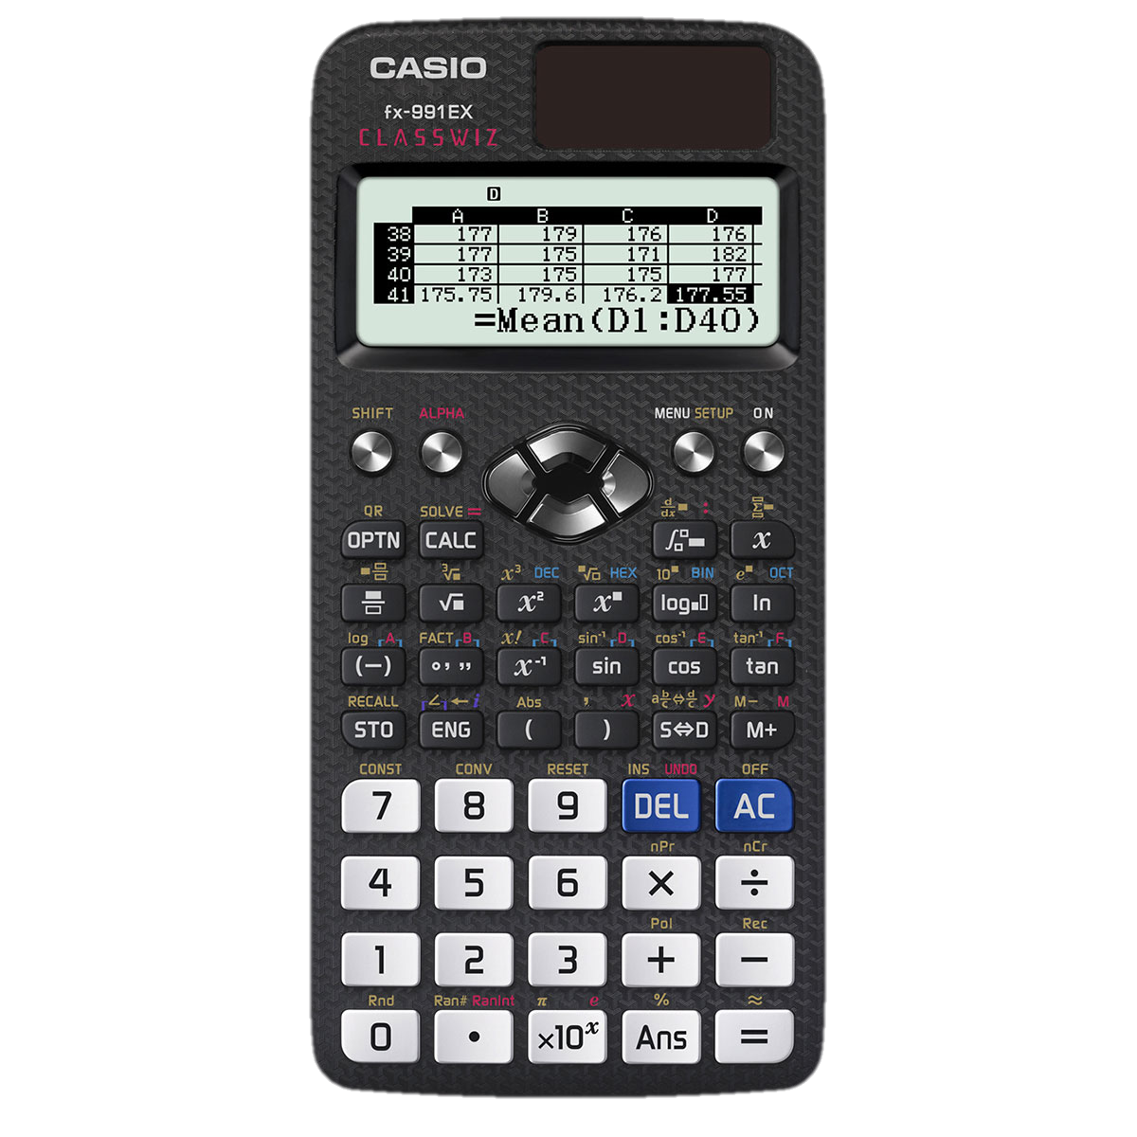
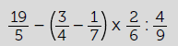
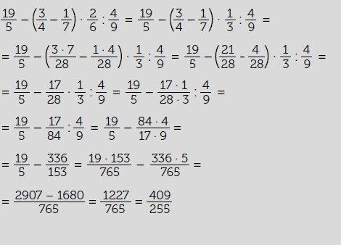
Check-Verify!
A math teacher has entrusted one of his students with the arduous task of solving section g) of exercise 89 of the textbook:
The student has made all the calculations and has found $\frac{409}{255}$ as a final result. However, they checked the result with the calculator and they have obtained a different value. Specifically, this:
Below are the calculations you have made:

What happened? In some step they have made a mistake, but what? Find the answer using your calculator.
1

Use the calculator to check other calculations that you had to do by hand.
2

This teaching material is written by the Federación Española de Sociedades de Profesores de Matemáticas (FESPM) and other authors.

You can use and alter the teaching material for educational purposes, however the use of it for the purpose of sales is prohibited.

