Scientific Notation
ARITHMETIC
13
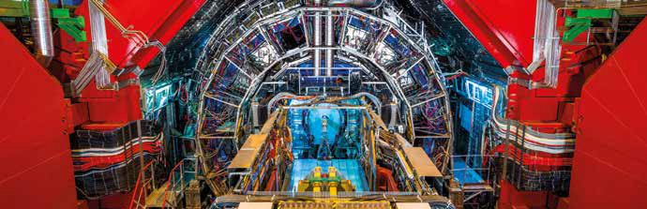
A numerical trip to CERN: between the infinite and the infinitely small (II)

The LHC, located at CERN, is the largest and most energetic particle accelerator in the world. It is a circular tunnel of 27 km in length inside which proton beams are accelerated in opposite directions at speeds close to light. When the particles collide, they produce very high energies at subatomic scale that allow simulating events that occurred immediately after the Big Bang.

The proton beams travel the 27 km long ring at high speeds, completing 11,000 rounds per second. How many meters do the protons travel in a minute??
1

In each of these beams there are 100,000,000,000 protons. Despite the huge amount of protons in each beam, a few grams of hydrogen are enough to provide protons to accelerate over the next million years. Check the validity of this statement.
2

To generate the magnetic fields that keep the proton beams confined within the LHC, coils made of 0.007 mm thick wires (ten times thinner than a human hair) formed by a niobium-titanium alloy are used. These wires support current currents of 12,000 amperes (more than 400 times the intensity of the cables used with common voltages). To get an idea of the amount of cable installed, if we align all the filaments used in the LHC magnets we could go and return to the Sun more than six times.
3

- a) Compare the installed cable length with the distances from the Sun to the different planets of the Solar system expressed in UA (1 AU = Earth-Sun distance ~ 150 × 106 km):
Sun – Mercury: 0.39 UA Sun – Venus: 0.72 UA Sun –Earth: 1.00 UA
Sun – Mars: 1.52 UA Sun – Jupiter: 5.20 UA Sun – Saturn: 9.54 UA Sun – Uranus: 19.19 UA
Sun – Neptune: 30.06 UA

- Bearing in mind that a clip has a thickness of the order of 1 mm, how many niobium-titanium conductive filaments fit in a clip?

After the collision of two beams of protons, temperatures that exceed more than 100,000 times the temperature of the center of the Sun are reached; however, the interior of the LHC is the coldest place in the known universe (1.9 K), as well as one of the most empty (with pressures of approximately 10-13 atm). They have to be maintained these conditions of pressure and temperature so that the property of superconductivity of the magnets is maintained. Considering that the absolute zero of temperature corresponds to -273 ºC, what percentage of absolute zero is reached inside the LHC?
4

This teaching material is written by the Federación Española de Sociedades de Profesores de Matemáticas (FESPM) and other authors.

You can use and alter the teaching material for educational purposes, however the use of it for the purpose of sales is prohibited.

