Scientific Notation
ARITHMETIC
12
A numerical trip to CERN: between the infinite and the infinitely small (I)
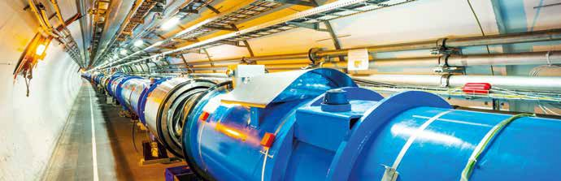

CERN is the most important research center in Europe. It has taken more than 30 years and an investment of € 6.5 billion to complete its construction. Dozens of Nobel Prize winners have used and continue to use their facilities.
The member countries of CERN (including Spain) finance their annual budget, which amounts to one billion Swiss francs (CHF), with public money.

Express in scientific notation the budget of CERN. Express this budget in euros (€) and in US dollars ($) according to the current exchange rate.[ 1 € = 1.14479 US $, 1 CHF = 0.90767 € ]
1

Compare the annual budget of CERN with the general budgets of the Spanish states for the year 2016, which amounted to 274,731.84 M €. (M means thousands)
2

During the operation of its facilities, CERN generates an electric bill of two hundred and fifty million euros per year. What percentage does this figure represent over your total budget?
3

The LHC (Large Hadron Collider) is the jewel in the crown of CERN. It is a particle accelerator that can accelerate protons to reach 0.9999999991 times the speed of light. How many kilometers does a proton moving at that speed in one of the acceleration rings of the LHC travel for one minute?
4

Compare the value you have obtained in the previous section with the estimated average distance between Earth and the Sun, of approximately 1.5 × 1011 m).
5

The LHC is an almost circular ring of 27 km in length. What is the radius of that ring? What inner surface does the ring contain? Compare that amount with the surface of a Soccer field (~ 1 ha) and with the surface of a cosmopolitan city like Barcelona (~ 100 km²)).
6

This teaching material is written by the Federación Española de Sociedades de Profesores de Matemáticas (FESPM) and other authors.

You can use and alter the teaching material for educational purposes, however the use of it for the purpose of sales is prohibited.

