Unidimensional statistics. Probability
14

Duck hunting
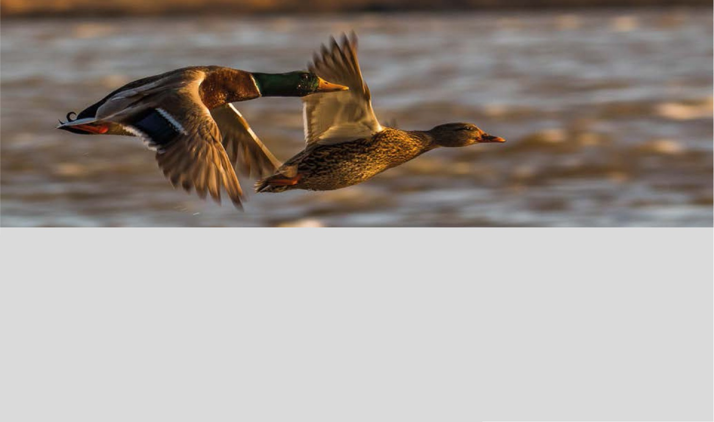

In 1973 Maurice Glaymann and Tamas Varga published “Les probabilités à l'ècole” (Collection Formation des maîtres en mathematique, 9). In 1975 the Teide publishing house published a translation by Ricardo Pons of the aforementioned book: Probabilities at School.
One of the best known examples from the book on simulation with random numbers is:
Duck hunting
"Ten hunters, all of them elite, are preparing to hunt ducks in front of rocks on which ten ducks are sitting. Each hunter can only take one shot and cannot know which ducks the others are shooting at. They all shoot at the same time, each choosing their victim at random. If this experiment is repeated often, how many ducks will survive on average?"

Six hunters, who never fail, shoot six ducks.
1
How many ducks, on average, are expected to survive the hunters’ shots?
Perform a simulation to calculate the number of ducks that will survive the shots of the hunters.

Calculate, from the simulation data of section 1, the probability that:
2
  - No ducks survive.
  - One duck survives.
  - Two, three, four or five ducks survive.

This teaching material is written by the Federación Española de Sociedades de Profesores de Matemáticas (FESPM) and other authors.

You can use and alter the teaching material for educational purposes, however the use of it for the purpose of sales is prohibited.

