Quadratic function

12

Area of a rectangle in an equilateral triangle

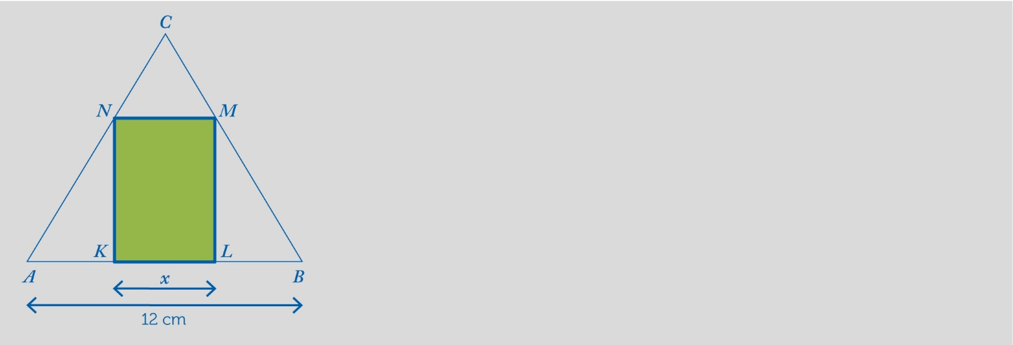

In an equilateral triangle with side $\overline{AB}$ = 12 cm in rectangle *KLMN*with side $\overline{KL}$ = *x*cm.

Calculate the area of rectangle *KLMN* for *x* = 2 cm.



**1**

Determine the area *S*(*x*) of rectangle *KLMN* as a function of *x* = $\overline{KL}$.



**2**

Complete the following table:



**3**

|  |  |
| --- | --- |
| ***x*** | **Area of *KLMN*** |
| 1 |  |
| 2 |  |
| 3 |  |
| 4 |  |
| 5 |  |
| 6 |  |
| 7 |  |
| 8 |  |
| *x* | *S*(*x*) |

Represent function *S*(*x*) graphically and describe its properties.



**4**

For what value of *x* is the area of rectangle *KLMN* at its maximum? Calculate said maximum area.



**5**

This teaching material is written by the Federación Española de Sociedades de Profesores de Matemáticas (FESPM) and other authors.

You can use and alter the teaching material for educational purposes, however the use of it for the purpose of sales is prohibited.