Probability calculation. Rule of succession
04

Condorcet's paradox
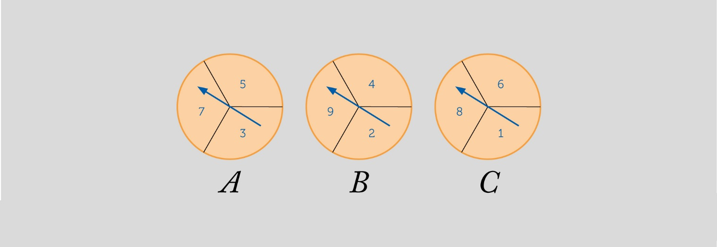
Three roulette wheels are provided like the ones in the image. The probability of the needle falling into any of the sections is the same, the sections are equiprobable.

Play in pairs, each choosing a roulette wheel and spinning needles. Whoever gets the highest number is the winner.

Search for information about Condorcet and write a review about him and what he is known for.
1

Find the following probabilities:
2
P(A beats B), P(B beats C), P(C beats A) P(B beats A), P(C beats B), P(A beats C)

If you have chosen roulette A, which one should your partner choose if they want to have a better chance of winning than you?
3

In a second game your partner gets the roulette they chose before, which one would you now choose?
4

In the next game, you keep the roulette you chose in part 4; which roulette should your partner choose if they want to have more chances of winning than you?
5

After several games, and choosing the roulette in the most favorable way, do you think any player has a better chance of winning?
6

This teaching material is written by the Federación Española de Sociedades de Profesores de Matemáticas (FESPM) and other authors.

You can use and alter the teaching material for educational purposes, however the use of it for the purpose of sales is prohibited.

