Rule of succession: Troubleshooting
03

My new license plate
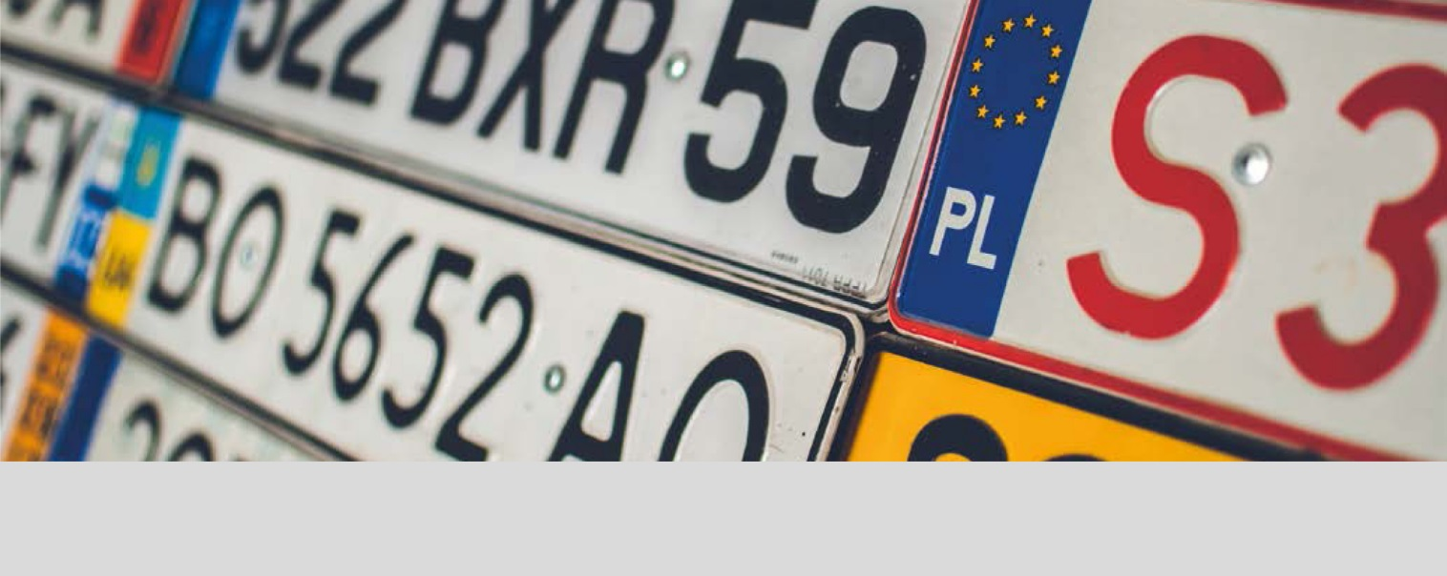

On September 18 2000, the new car registration system came into force, introducing plates with four-digits and three consonants, with the exception of the letters Ñ and Q.

How many different license plates can be created with this system?
1

I bought a new car and the office told me it would be registered tomorrow.
2
What is the probability of my license plate having a perfect four-digit square?

What is the probability of a four-digit number having a perfect square?
3

This teaching material is written by the Federación Española de Sociedades de Profesores de Matemáticas (FESPM) and other authors.

You can use and alter the teaching material for educational purposes, however the use of it for the purpose of sales is prohibited.

