Identification type of numbers
ARITHMETIC
09

Numerical properties of the golden number

Be a segment $\overline{AB}$ and an interior point E that divides it into two segments$\overline{ AE}$ and $\overline{EB}$. It is said that point E divides the $\overline{AB}$ segment in golden proportion (or in average and extreme ratio) if it is fulfilled that:

The ratio of proportionality Φ is known as a gold number or a golden number. To perform the golden division of an $\overline{AB}$ segment, proceed as follows:
- Draw segment $\overline{BC}$ perpendicular to $\overline{AB}$ such that $\overline{BC}=\frac{1}{2}\overline{AB}$
- Draw segment $\overline{AC}$
- Draw an arc with radius $\overline{BC}$ from C and mark the point of intersection D with the segment to $\overline{AC}$.
- An arc is drawn from A of radius $\overline{AD}$ and is considered the point of intersection, E, with segment $\overline{AB}$.

You can check that $\frac{\overline{AB}}{\overline{AE}}=\frac{\overline{AE}}{\overline{EB}}=Φ with Φ=\frac{1+\sqrt{5}}{2}$

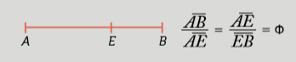

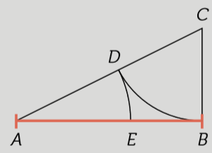

Show the following properties of the gold number:

It is the positive solution of the quadratic equation x2 – x – 1 = 0.
1

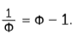
Verify the following equalities: Φ2 = 1 + Φ and
2

Its successive powers form a succession of Fibonacci.
3

lim = Φ
4
+ + + ...

lim 1 + = Φ
5
1 +
1 +
1 + 1 + ...

This teaching material is written by the Federación Española de Sociedades de Profesores de Matemáticas (FESPM) and other authors.

You can use and alter the teaching material for educational purposes, however the use of it for the purpose of sales is prohibited.

