Parameters: calculation and interpretation
STATISTICS
03
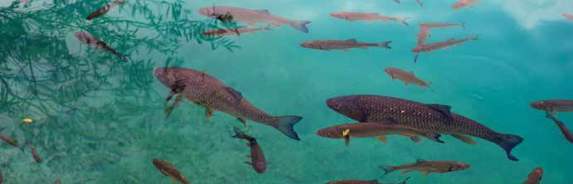
How many fish are in the lake?

How could you know the number of fish in a lake? And the number of rabbits in a mountain? To answer questions of this type, estimates are usually made.
Next, a method will be developed that allows an estimation of the total population from a sample. For this, it is convenient to form groups and follow these steps:
• In an opaque bottle an unknown number of balls are inserted, all of them of the same color.
• 10 balls are removed and replaced by 10 balls of different colors. Then mix with the rest of the balls of the bottle.
• Each group then extracts 10 balls.
• Write down the number of balls that are of the different color, repeat the experiment 20 times and collect the data in a table like the following:

Number of balls changed | 0 | 1 | 2 | 3 | 4 | 5 | 6 | 7 | 8 | 9 | 10 | TOTAL
Frequency |  |  |  |  |  |  |  |  |  |  |  | 20

From the information collected in the table, can you estimate the number of differntt colored balls in the bottle? How would you do it?
1

Combine your all the groups data. Enter in the calculator the frequencies for each number of balls of the changed color and share them with the group. Calculate the average from the shared data.
2

Now open the bottle and count the number of balls there are. Calculate the error made when working with your small group's data with that of the class data.
3

Do you think the method you have followed is valid? How could you improve it?
4

This teaching material is written by the Federación Española de Sociedades de Profesores de Matemáticas (FESPM) and other authors.

You can use and alter the teaching material for educational purposes, however the use of it for the purpose of sales is prohibited.

