Parameters: calculation and interpretation
STATISTICS

01
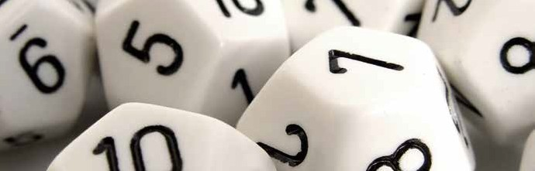
Dodecahedral Dice

Look at the dodecahedra in the image. How many faces do they have? What are the polygons that make up faces called?
What is a regular polyhedron? What are the regular polyhedral? What is the relationship between edges, faces and vertices?

Throw a dodecahedral dice 50 times, write down the results and build a table of frequencies like the following:
1

Result | Frequency | Relative frequency
1
2
3
4
5
6
7
8
9
10
11
12
Total

Remember that the frequency is the number of observations of each data and is usually represented by the letter F and a subscript, Fi.
To relate data in two situations with a number of different observations, the concept of relative frequency is introduced, which is defined as the quotient between the frequency and the total of the observations. It is represented with f i.
It represents the bar chart of the absolute frequencies and that of the relative frequencies. Discuss the differences and similarities between the two diagrams.
2
What is the average of the scores obtained?
3
4
5
6
Compare the average you have obtained with that of your classmates. Calculate the average of all the means. What is the result?
Now, put all the data together with your group. To do this, enter your data in the calculator and
Share them with the group using the CASIO EDU + application. Copy in your notebook the table of absolute frequencies of the whole class and calculate the average. What result have you obtained?
What relationship exists between the two obtained means? Do you think that happens always?
7

This teaching material is written by the Federación Española de Sociedades de Profesores de Matemáticas (FESPM) and other authors.

You can use and alter the teaching material for educational purposes, however the use of it for the purpose of sales is prohibited.

