Relative Frequency
STATISTICS
02
Colored billiard balls
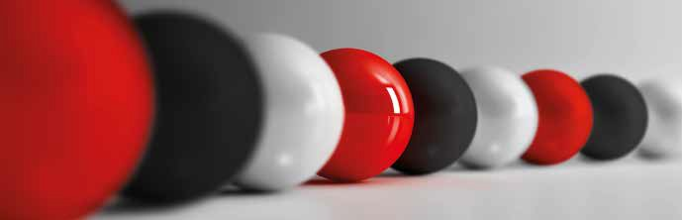
In an opaque cloth bag, 20 balls of three different colors (red, white and black) have been introduced, but it is unknown how many balls are of each type.
One way to find out is to perform 50 extractions with replacement (that is, a ball is removed from the bag, the color is written down and returned to the bag).

Make the experiment that has been indicated and write down the results you get in the column corresponding to your group of a table like the following:
1

 | G1 | G2 | G3 | G4 | G5 | G6 | TOTAL
Red balls
White balls
Black balls
TOTAL
How many of each color are there?

Another bag contains colored balls (red, white, black and green), but in this case, it is unknown how many balls there are and what colors they are. To know the percentage of balls of each color, proceed as in the previous activity and complete the following table, noting the color of the balls extracted and the corresponding frequencies:
2

 | G1 | G2 | G3 | G4 | G5 | G6 | TOTAL
Red Balls
White balls
Black balls
Green balls
TOTAL
How many of each color are there?

This teaching material is written by the Federación Española de Sociedades de Profesores de Matemáticas (FESPM) and other authors.

You can use and alter the teaching material for educational purposes, however the use of it for the purpose of sales is prohibited.

