Scientific Notation
ARITHMETIC
14
Back to the Big Bang: the timeline of the Universe (I)

CERN is the most important physical research center in Europe and one of the most important in the world. Dozens of Nobel Prize winners have used and use their facilities. Scientific research at CERN makes use of large particle accelerators in which billions of collisions are generated, which are analyzed by a complex computer system that filters, collects and distributes the data.

The largest of the accelerators, currently in operation in the particle physics laboratory, is the LHC (Large Hadron Collider). The energy density and temperature that is reached in the LHC is similar to that which the theoretical models predict that there were moments after the Big Bang. That is why physicists hope to discover how the Universe has evolved from its origin to its current state, analyzing the data obtained from the LHC.

One of the conceptual difficulties with which we find ourselves at the time of understanding the studies of particle physics and cosmology are the tiny and / or gigantic values ​​of the temporal and energetic scales.

Observe the following infographic, which shows a series of cosmological events from which the orders of magnitude corresponding to three physical magnitudes are provided: time (t), temperature (T) and energy (E).

As you can see in the image, the cosmological events are located concentrically at different radial distances from the central point, which represents the Big Bang, to the outermost perimeter, which represents our days.
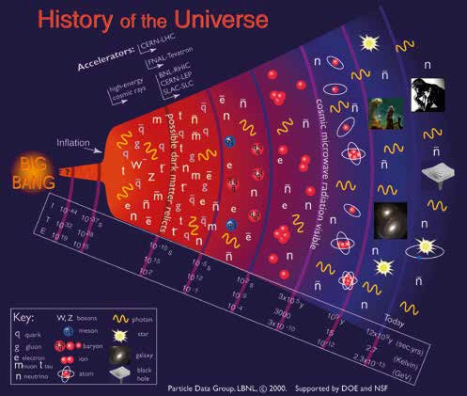

What is the relationship between the temporal values associated with different cosmological events and the distances to which they are located in the Big Bang in the infographic?
1

This teaching material is written by the Federación Española de Sociedades de Profesores de Matemáticas (FESPM) and other authors.

You can use and alter the teaching material for educational purposes, however the use of it for the purpose of sales is prohibited.

